**Module 10 – Single Page Application framework – React**

**13.ReactJS-HOL**

**1.Explain various ways of conditional rendering in React:**  
In React, conditional rendering is used to show or hide components or elements based on some logic or condition. There are different ways to do this:

* Using if / else statement:

if (isLoggedIn) {

return <Dashboard />;

} else {

return <LoginPage />;

}

* Using ternary operator:

{isDark ? <DarkTheme /> : <LightTheme />}

* Using logical AND (&&) operator:

{showMsg && <Message />}

* Using switch statement inside a function to choose a component:

switch(view) {

case 'book': return <BookDetails />;

case 'course': return <CourseDetails />;

default: return <Home />;

}

**2.Explain how to render multiple components:**  
In React, we can render more than one component at a time by wrapping them inside a fragment. This allows us to return multiple elements without using extra divs.

Example:

return (

<>

<Header />

<Navbar />

<MainContent />

<Footer />

</>

);

We can also store multiple components in an array and render them.

**3.Define list component:**  
A list component is a component in React that displays a list of items using map function. It is mostly used when we have to display data like books, users, posts, etc.

Example:

const fruits = ['Apple', 'Mango', 'Orange'];

return (

<ul>

{fruits.map((fruit, index) => <li key={index}>{fruit}</li>)}

</ul>

);

**4.Explain about keys in React applications:**  
Keys are used in React when rendering a list. A key is a special string attribute that helps React identify which items in a list are changed, added, or removed. Keys should be unique and preferably based on id.

Example:

users.map(user => <li key={user.id}>{user.name}</li>)

If we don't use keys, React will not be able to track changes efficiently, which can cause problems during re-rendering.

**5.Explain how to extract components with keys:**  
When we break list items into separate components, we must pass the key to the component while rendering it, not inside the component.

Wrong way:

<UserCard user={user} />

Correct way:

<UserCard key={user.id} user={user} />

This helps React to keep track of each component uniquely in a list.

**6.Explain React map, map() function:**  
The map() function is used to loop over arrays and return elements for each item. In React, map is mainly used to display lists of data.

Syntax:

array.map((item, index) => {

return <p key={index}>{item}</p>

});

Example:

const names = ['Asha', 'Deepa', 'Keerthi'];

return (

<div>

{names.map((n, i) => <h3 key={i}>{n}</h3>)}

</div>

);

**Structure:**

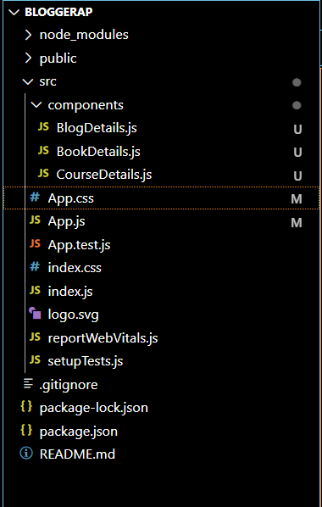

**BlogDetails.js:**

import React from 'react';

const blogs = [

  {

    title: 'React Learning',

    author: 'Stephen Biz',

    content: 'Welcome to learning React!'

  },

  {

    title: 'Installation',

    author: 'Schwezdenier',

    content: 'You can install React from npm.'

  }

];

function BlogDetails() {

  return (

    <div className="column">

      <h2>Blog Details</h2>

      {blogs.map((blog, index) => (

        <div key={index}>

          <h3>{blog.title}</h3>

          <strong>{blog.author}</strong>

          <p>{blog.content}</p>

        </div>

      ))}

    </div>

  );

}

export default BlogDetails;

**BookDetails.js:**

import React from 'react';

const books = [

  { title: 'Master React', price: 670 },

  { title: 'Deep Dive into Angular 11', price: 800 },

  { title: 'Mongo Essentials', price: 450 }

];

function BookDetails() {

  return (

    <div className="column">

      <h2>Book Details</h2>

      {books.map((book, index) => (

        <div key={index}>

          <h3>{book.title}</h3>

          <p>{book.price}</p>

        </div>

      ))}

    </div>

  );

}

export default BookDetails;

**CourseDetails.js:**

import React from 'react';

const courses = [

  { title: 'Angular', date: '4/5/2021' },

  { title: 'React', date: '6/3/2021' }

];

function CourseDetails() {

  return (

    <div className="column">

      <h2>Course Details</h2>

      {courses.map((course, index) => (

        <div key={index}>

          <h3>{course.title}</h3>

          <p>{course.date}</p>

        </div>

      ))}

    </div>

  );

}

export default CourseDetails;

**Output:**

